Financial Mathematics Topic Test
Part 2
Name: _________________

- A real-estate salesman is paid a retainer of $700/week and 5% of sales over $200000. 2
In a good week they sold $570000 worth of property. What was his gross pay?

- Tim wrote a popular song and is paid $0.35 for each CD sold. If 1.2 million are sold how much does he receive? 1

- Gerry earns $1200 per week. 3

  - Calculate his annual leave loading at 17.5% for 4 weeks.

  - What is his gross holiday pay?

- Explain the difference between each of the following sources of government income. 4

  - Youth Allowance

  - Austudy

  - Newstart Allowance

  - Disability Support Pension

- What is a tax file number used for? 1

- Barry earns $45 864 p.a. and has the following deductions. 6

Tax,
6% superannuation,
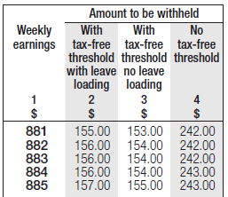
$57 to a health fund,
$9 union fees
and a $40 000 HELP debt.

  - What is his weekly wage?

  - How much tax does he pay?

  - What is his superannuation contribution in dollars?

  - What is his minimum HELP contribution for the year in dollars?

  - What is his weekly deduction for his HELP loan?

HELP repayment  income (HRI*) | Repayment rate
Below $43,151 | Nil
$43,151–$48,066 | 4% of HRI
$48,067–$52,980 | 4.5% of HRI
$52,981–$55,764 | 5% of HRI
$55,765–$59,943 | 5.5% of HRI

  - What is his net pay?

- In a week John earns $540.00, has $10 bank interest and a gift of $50 from his sister. He puts $30 away for electricity, $120 for his contribution to rent, $50 for food, $20 for his telephone and $100 for entertainment. Create a budget below. 4

Weekly Budget
Income |  | Expenditure
 |  | Savings
Total |  | Total

